This project is published on to this.

<http://geragrgarg.cloudapp.net/>

But when login is clicked the page just loads and nothing happens.

But it works when run on local.



This is the main page where the user can login as an admin or a client. This is different from what I had in the first spec because the password is removed. The user can type “Admin” to login as admin or type there name to login as client. The init button removes all albums in the table and creates 5 start-up albums.

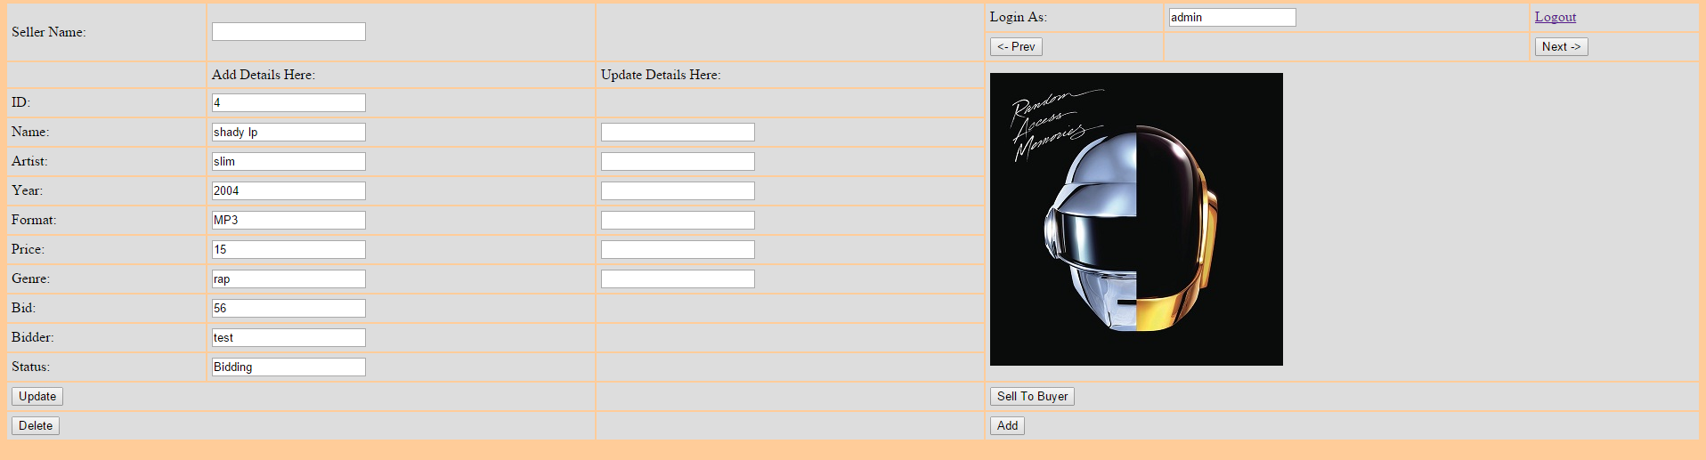

This is the admin page. This lets user/admin to add album, edit albums, delete albums or set albums.

Example of details being updated.

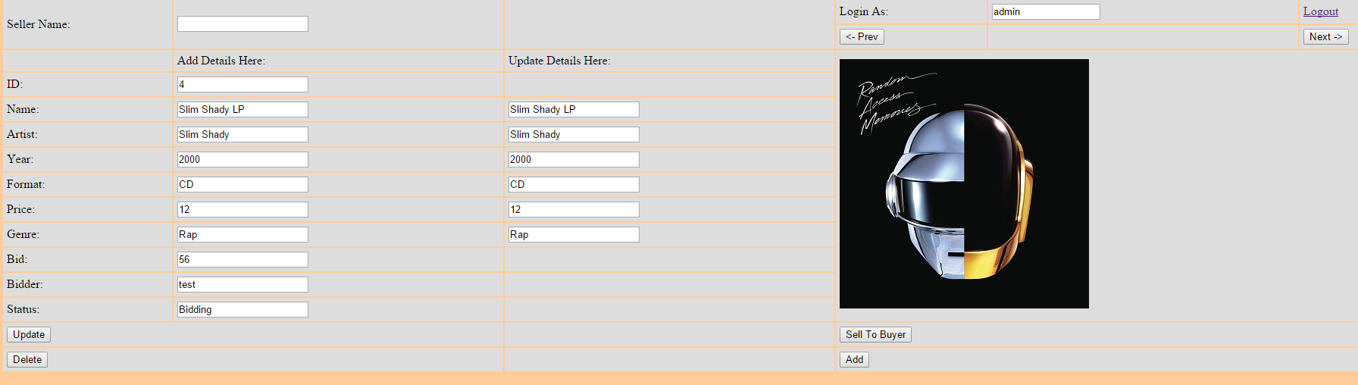

Example of albums deleted.

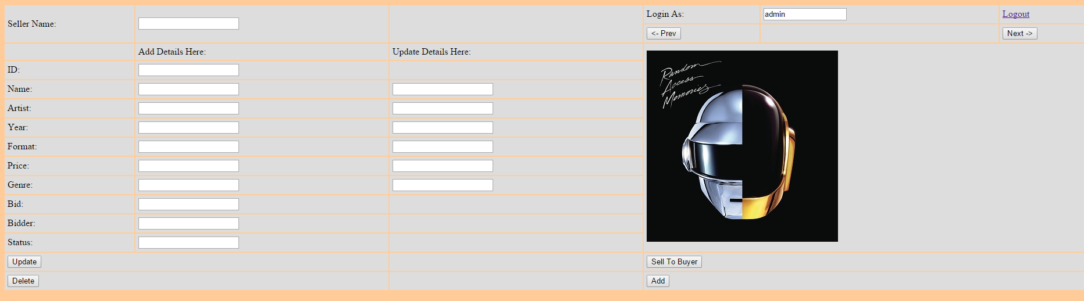

Example of an album added.

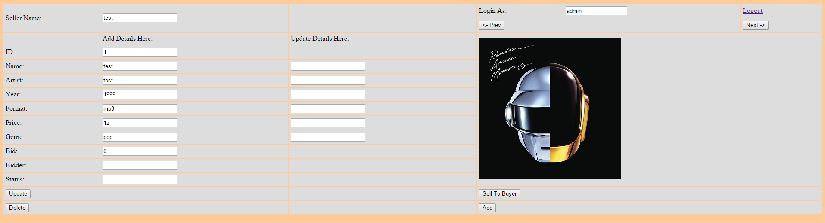

The client page.

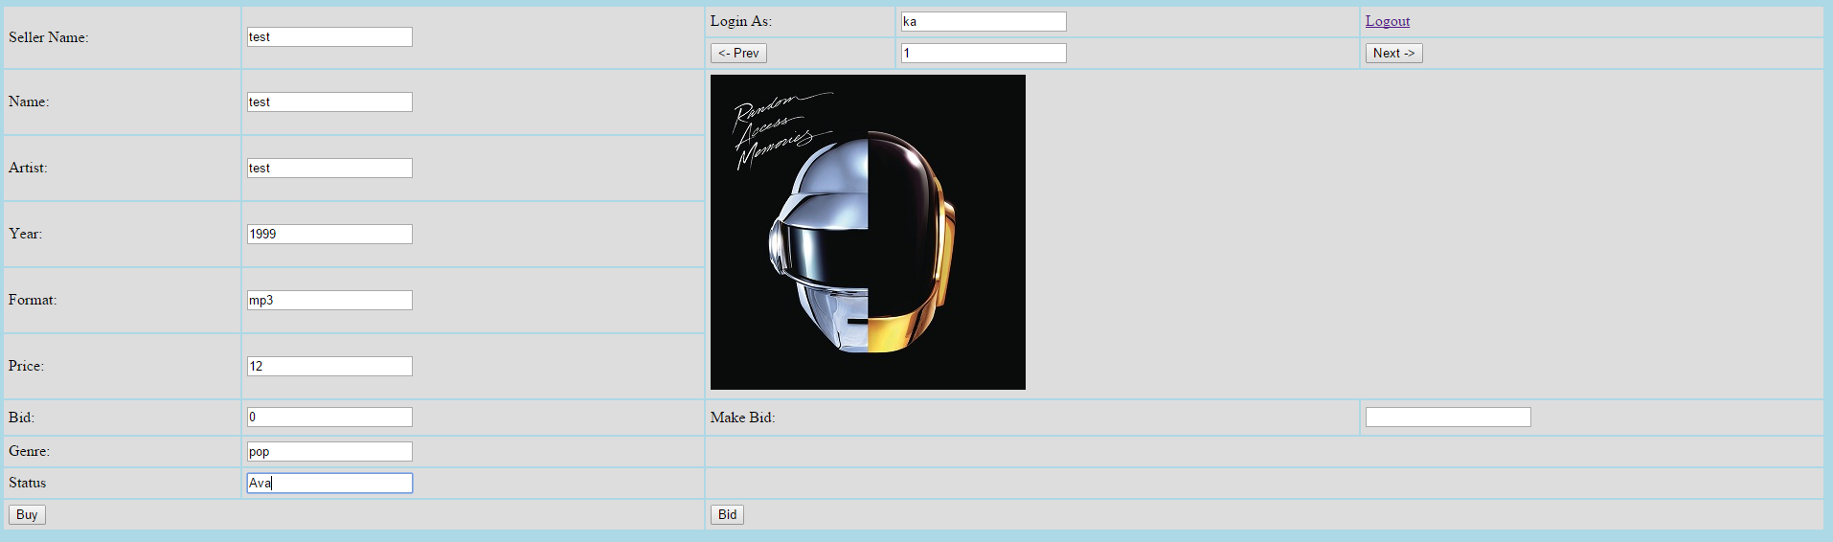

User can bid. When bid the status becomes bidding and users can’t buy it but can bid higher.

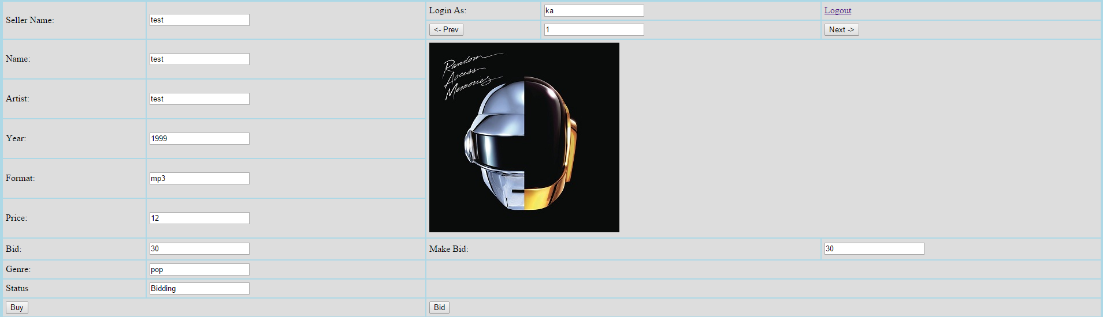

When bid is too low



When user tries to buy a bidding album.

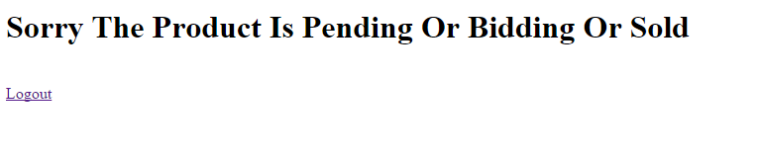

Now admin can sell to bidder

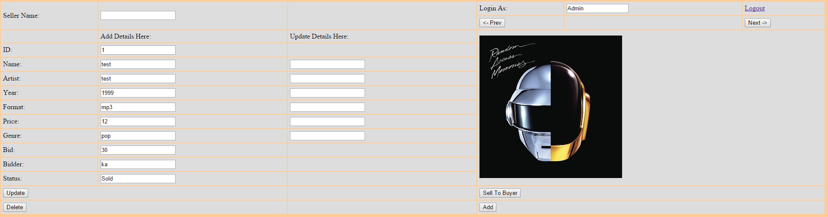

Status becomes sold.

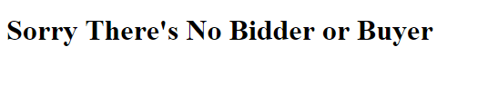

When there’s no buyer or bidder.

The next and pervious button works but it only display some and some don’t get displayed.